**How to Build a Doctor Booking App for Healthcare Appointments with React Native**

**Looking for the potential ways to manage your clinical operations and patient bookings? Hire a mobile app development company to develop an online doctor appointment booking app and enjoy hassle free scheduling.**

[](https://saraakhaan121.medium.com/?source=post_page-----c3ddf4bb40af--------------------------------)

[Sara Khan](https://saraakhaan121.medium.com/?source=post_page-----c3ddf4bb40af--------------------------------)

[Follow](https://medium.com/m/signin?actionUrl=https%3A%2F%2Fmedium.com%2F_%2Fsubscribe%2Fuser%2Fa92c054f548d&operation=register&redirect=https%3A%2F%2Fjavascript.plainenglish.io%2Fhow-to-build-a-doctor-booking-app-for-healthcare-appointments-with-react-native-c3ddf4bb40af&source=post_page-a92c054f548d----c3ddf4bb40af---------------------follow_byline-----------)

[May 11](https://javascript.plainenglish.io/how-to-build-a-doctor-booking-app-for-healthcare-appointments-with-react-native-c3ddf4bb40af?source=post_page-----c3ddf4bb40af--------------------------------) · 11 min read

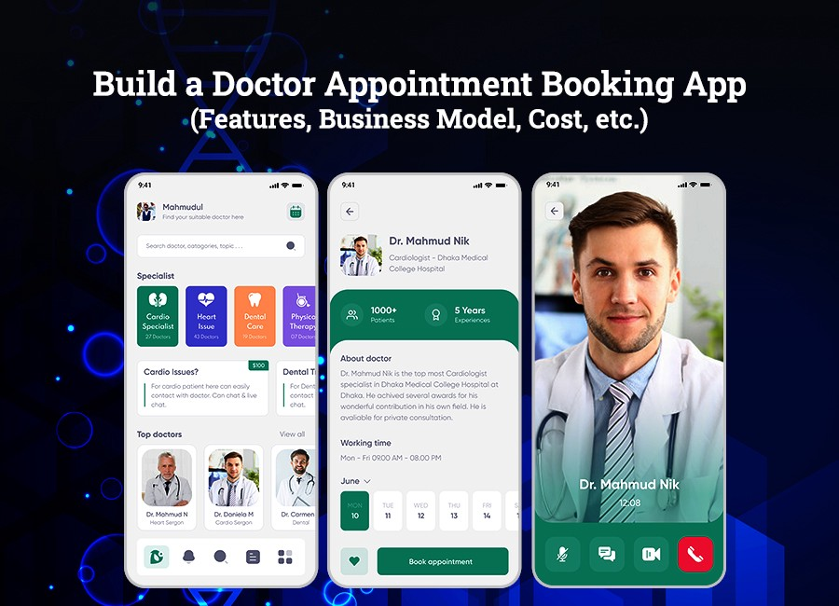

Many of us have memories associated with the hospital. The long queues at the reception, the long hours waiting to fix an appointment, the awkwardness of facing panic-ridden patients while sitting in the waiting room, and that distinct “hospital” odour.

*Of course, it’s terrible to remember!*

But luckily, all thanks to this on-demand doctor appointment booking app, such hassles can be put to an end.

If you are one of those who is tired of managing throngs of patients lining up in the clinic’s waiting room, then it’s a sign you should probably look to investing in an online doctor’s appointment booking app that helps you streamline your work as per your availability.

**Why has it become so important to invest in a doctor’s appointment booking app?**

With the fact that emerging technologies are strongly paving their way into the healthcare sector, more and more patients are switching to mHealthcare (mobile healthcare). *Let us take you through the market stats that explain to you how the patient’s psychology is changing and why they are shifting to online healthcare services.*

* [According to the study](https://www.lsainsights.com/), 60% of consumers run a Google search before scheduling an appointment with a physical therapist, nursing home, or other doctors.
* [94% of patients](https://www.softwareadvice.com/resources/how-patients-use-online-reviews/) seeking healthcare services use online reviews before fixing an appointment with the doctor.
* [81% of consumers](https://www.dialogtech.com/blog/health-care-marketing-statistics/) are unsatisfied with their healthcare experience, therefore, they are likely to check online reviews.
* [2.4% of healthcare appointments](https://www.accenture.com/us-en) are scheduled online to avoid waiting.
* [19% of smartphone owners](https://thesparkreport.com/infographic-social-mobile-healthcare/) have at least one healthcare app on their phone whether it be exercise, diet, weight app or doctor consultation app.
* [54% of patients](https://getreferralmd.com/2013/09/healthcare-social-media-statistics/) are very comfortable with their providers seeking advice from online communities to better treat their conditions.
* The mobile healthcare sector is predicted to become an industry of [$300 billion by 2025](https://blog.capterra.com/top-7-medical-apps-for-doctors/).
* The telehealth industry is expected to grow by [19% by the end of 2025](https://www.gminsights.com/industry-analysis/telemedicine-market).

***In a nutshell:****The mobile healthcare stats and facts are portraying the rising trend of accessing virtual clinics at the steep. For clinics that are looking for potential ways to streamline their clinical operations or patients who are always on the go, these on-demand doctor booking apps are proving to be key.*

Now the central question here is how to [**develop a successful on-demand doctor booking app**](https://www.xicom.ae/services/mobile-app-development/) for your clinic or hospital?

Let’s have a look at a step-by-step guide for building a doctor’s appointment booking app.

**How to Build a Doctor’s Appointment Booking App in 2021**

While the world is scrambling with lots of technologies, tools, and frameworks, designing, developing, and launching a fail-proof app that meets the needs of the end-users seems to be a tough task. So here, we will guide you step-by-step to develop a doctor’s appointment booking app that will help you stay ahead in the competitive market.

How do you create a powerful medical scheduling app with all the features your patients need? If you don’t have a technical team, then you can choose to hire a mobile app development company that will help you build a doctor’s appointment app and take care of both frontend and backend for you.

*But still, we have framed out easy steps to create a doctor’s appointment booking app:*

**Step 1 — Research The Market**

Before starting the design and development of an online doctor appointment system, do in-depth market research. The functionality of your app will depend on your location, target audience, business model and more.

If you are trying to enter into the patient appointment mobile app development, then it is important to gather some important facts by [**hiring an app developer**](https://www.xicom.ae/solutions/hire-developers/) that helps you learn from the competitors. Following their business models and learning from their mistakes will cut down on your initial efforts and help you turn them into your assets.

***So basically, while researching a market, you need to:***

* Take a closer look at your competitor’s app, its interface, features, technologies, and so on.
* Analyse their pros and cons.
* Frame out the points where they missed to reach the end needs.
* Check what platform they have chosen to launch their app- iOS, Android, or both.
* Verify whether they have two apps, one for patients and one for doctors.
* Combine all of this with your patient’s needs.

**Step 2 — Plan The Feature Set**

The next step is to pick the features you want your app to have. Depending upon your needs and budget, you can go with the MVP model or select advanced functions for your app. But to stay ahead in the competitive market, experts recommend you to go for the second option.

***But when you start sorting the features for your app, keep in mind that there are three panels — Patient, Doctor, and Admin.***



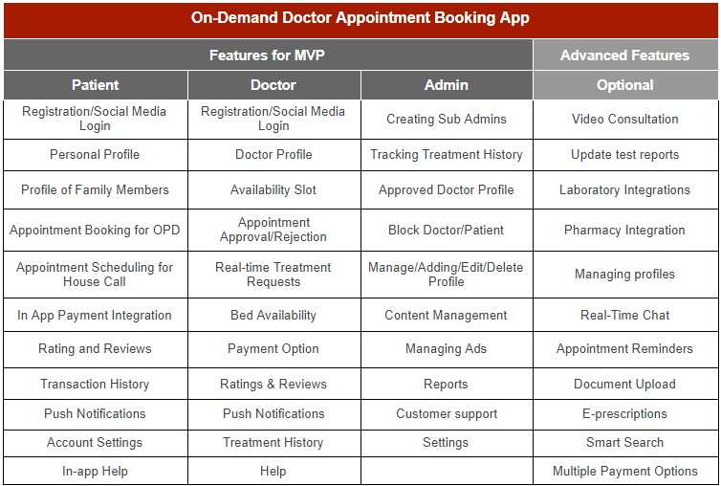

**Step 3 — Verify a Prototype**

Once you have decided on the app’s structure, it’s time to think about the on-demand app development prototype. You need to develop the visuals of all screens in the app and verify its features with a clickthrough prototype.

***For prototyping, we prefer to use Invision, but developers are free to use other prototyping tools, for example:***

* [Adobe XD](https://www.adobe.com/products/xd/solutions/prototyping-tool.html)
* [Figma](https://www.figma.com/prototyping/)
* [Sketch](https://www.sketch.com/docs/prototyping/)

***With the help of these tools you can better decide on:***

* User interface
* Color, patterns, and other visuals in your app
* Easy to navigate booking system
* Fine-tine it for iOS and Android

**Step 4 — Review Off-the-Shelf Scheduling Tools**

When you decide to create a doctor appointment scheduling app, the most time-draining chunk will be developing a scheduling engine. Especially if you build an app from scratch. The better option is to pick an off-the-shelf scheduling API like those provided by Acuity, Timekit, or OnSched.

Since we are developing an on-demand doctor appointment booking app with React Native, it is a worthy decision to use APIs supported by React Native that can significantly speed up the custom mobile app development process, but keep in mind that this choice will influence your UI.

**Why Choose React Native for a Healthcare Appointment Booking App?**

Assuming that you are well familiar with the fact that it is one of the frameworks, widely used for [**cross-platform app development solutions**](https://www.xicom.ae/services/cross-platform-app-development/) and highly in demand for front-end development. Despite being a young framework based on JavaScript, it is holding the trust of leading corporates including Myntra, Tesla, Facebook, Amazon, and more.

***Reasons are here:***

* React Native uses the same code for web, Android, and iOS platform, therefore, reduced the development efforts by almost 50% without compromising the quality and productivity.
* Developing an app right from the scratch is an expensive deal, though React Native provides a huge JavaScript library that revolutionizes workflow and enhances app performance.
* Ensuring better UI/UX as like Native experience.
* React Native is a perfect platform for building MVP that provides great flexibility and productivity. In addition, it supports quick development, code reusability, third-party plugin support, simplified UI, a vast collection of libraries that make this framework a top choice for development.
* It is one of the top cross-platform frameworks for mobile app development that leverages Facebook’s rich UI library that makes easily implementable and executable code similar to React.

**Step 5 — App Development Process**

Undoubtedly, coding an app is a complex and boring task for developers, but it can be exciting while [**creating an on-demand doctor booking app**](https://www.xicom.ae/services/mobile-app-development/). Not only does RN provide you good support of a wide choice of plugins, but it also helps you develop multiple applications by using a single codebase. All you need is to hire a cross-platform app developer that has experience and knowledge of developing an app that makes it comply with all AppStore and PlayStore rules.

**Step 6 — Quality Assurance**

Before rushing to launch your app to the app store, it makes sense to go through a set of rigorous tests and quality assurance processes. These tests ensure that on-demand applications are capable of delivering optimum performance by fixing the bugs before the launch. Make sure that the application passes through rigorous speed testing, unit testing, security testing, load testing, and regression testing.

**Step 7 — Launch The App**

No matter how brilliant an app you have developed, it will not give you any benefit until you will not market the booking app effectively in the app store. *Telling your patient is the first step and then proceed to the marketing strategies which may include:*

* Pushing the app on your doctor’s official website.
* Sending a bulk email to the patient list.
* Sharing details on social media.
* Advertising on the app stores and health care business.

If you are thinking that your job is done, then you might be mistaken. Developing and launching an app is not as seamless as it may sound. So let’s understand the challenges of launching the doctor booking app in 2021!

**Major Speed Breakers for Creating the Health Booking App**

Though developing any kind of app is not a far-fetched job for developers, but still, by hiring a mobile app development company, you can build an amazing application for your business. But to be practical, while developing the application, there are a number of cliffhangers that you have to overcome. And here’s the list of speed breakers:

***Challenge #1****The first and the most common challenges that developers deal with, while they induce the video call facility into the application.*

* **Pro solution:** To successfully implement the video calling feature to the doctor booking app, you need to use the programmable video services of Twilio.

***Challenge #2****Another challenge is to track the exact location of the doctor’s clinic to check the proximity with the patient.*

* **Pro Solution:**You can [**hire mobile app developers**](https://www.xicom.ae/services/mobile-app-developers/) to overcome this challenge or use Google’s GeoLocation feature to fetch accurate data.

This is not all you need to focus on while developing an on-demand doctor booking app for your clinic. With the increasing demand of these healthcare booking apps, such apps like ZocDoc and Practo, which are already two major leading appointment booking apps for the doctors that are dominating this category. So how would you win the trust of users?

**How to build trust in your app for doctor appointment bookings?**

Whether you are following any clone of the leading applications or developing it right from the scratch by hiring the mobile app development company, your main focus must be on the end-users. ***So considering this fact, here are the few simple yet basic things to follow if you really wish to win the trust of users on your app:***

* *Your app should be easy to use and simple to navigate.*
* *User interface is important so keep it simple, engaging and attractive.*
* *Apps must be easy to install and get started with a quick sign-up.*
* *It should easily sync data across the various devices.*
* *Should be safe and secure to access as it preserves the user data.*

Healthcare mobile app development should contain excellent UX/UI design, analytics, quality assurance, backend, and app development. To keep your app ahead of the competition, here we have listed some of the important features to be integrated into the app that helps you win the trust of the users:

* **Doctor’s Profile Scanning**

Before listing any doctor to your app, make sure you have a thorough verification process in-app. For instance, Practo only publishes a profile when a doctor provides his registration number and scanned copies of the certificates or ID.

* **Accurate Indication of Doctor’s Experience**

You need to incorporate as many as possible ways to check out the doctor’s experience before approving their profile. You can [**hire an app developer**](https://www.xicom.ae/solutions/hire-developers/) experienced with ML, data science, or AI that enables you to pick the best suitable approach for data gathering.

* **Genuine Ratings and Reviews**

Another aim is to convince users of the authenticity of reviews for your app. While every app has this section, here are a handful of tips on how you can perform this a little better:

* *Allow only verified patients to post the reviews after their confirmed appointments.*
* *Make sure that feedback must be given once in a lifetime and it can be checked through the mobile number verification.*
* *SMS can be sent on patients’ mobile numbers after their appointment.*

Now you have developed your app with the best features integrated into it. But the major question remains unanswered: how to make a profit from your appointment booking app.

**Best Business Models for Doctor Appointment Booking App**

Instead of wasting time with an introduction, let’s quickly look at the main ways in which you can make money with on-demand healthcare apps:

* **Incorporate Premium Services:** Such premium services may extend the facility of accessing unlimited doctors, access to AI physicians, online prescriptions, medicine delivery, and more.
* **Offer Subscription Packages:** All users can switch to paid accounts to leverage extended features with better facilities.
* **Charging a Fee on Each Appointment:** This is how most healthcare apps make money. They charge a partial amount as a fee from doctors on each appointment in the form of commission.

**How Much Will It Cost to Develop a Doctor Booking App?**

Calculating the cost of creating a doctor appointment booking app for your clinic is the real struggle as the cost majorly depends on the functionality, features, complexity and UX/UI design that you integrate into your app. The app can be simple that includes doctor appointment booking with the text message or it can be an advanced level that integrates a plethora of features and advanced functionalities. The structure of the app totally depends on your budget and your end-users.

*Let’s find out how must it will cost you while developing with React Native:*

**Features to be Expected in Your App**

* Appointment reminder
* Online doctor booking
* Medicine delivery
* Medicine reminder
* E-prescription Uploading
* Medical history
* Doctor mapping as per location
* Access to blogs of health experts

**Technologies That Need to be Integrated**

* Backend Development: Java, .Net, Python
* Development Hours: 1200+
* Frontend Development: React Native, Angular
* Development Hours: 800+
* Platform Availability: Android, iOS
* Blog Functionality: WordPress
* Development Hours: 100+

**Development Team Required**

* Quality Assurance
* NetOps
* Business Analyst
* UX/UI Design

***In this specific case, the estimated price of developing a doctor booking app with React Native can be starting from $20,000+. But the cost to develop a basic or modern version of this app can’t be starting from $10,000.***

**Wrapping up**

To end this blog, we agree with the fact that the healthcare industry is crowded, but there is always room for improvement and innovation.

A lot of healthcare appointment apps are available in the market and are still in need of providing a better user experience. So, it makes sense to hire a [**mobile app development company**](https://www.xicom.ae/services/mobile-app-development/) that leverages the best technologies in the app development process and allows you to stay ahead in the competitive market.

*Hopefully, this blog has answered all your concerns related to developing a successful on-demand doctor booking app. But still, if you have any doubts, then you can drop a query in the comments below.*

*More content at*[*plainenglish.io*](http://plainenglish.io/)